Breath and Beyond:
The Basics and Then Some!

Key Information:

PREPARE yourself physically and mentally before you rehearse/perform!

- Most singing problems occur before you begin to sing!

- Body Alignment (The “P” Word!)

- Good body alignment is the basis for all good singing
- Proper skeletal and muscular alignment prevents unnecessary muscular tension and fatigue, and places all parts of the vocal instrument in their most efficient working position
- Make it automatic!

Breathing and Breath Support

- The difference between breathing to live and breathing to sing is the amount of conscious control exerted

- Four Stages: Muscle Systems Used:
- Inhalation - Back
- Suspension - Ribs (Intercostals)
- Exhalation - Upper Abdomen
- Recovery - Lower Abdomen
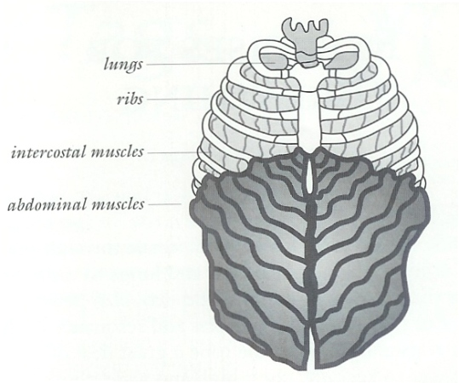

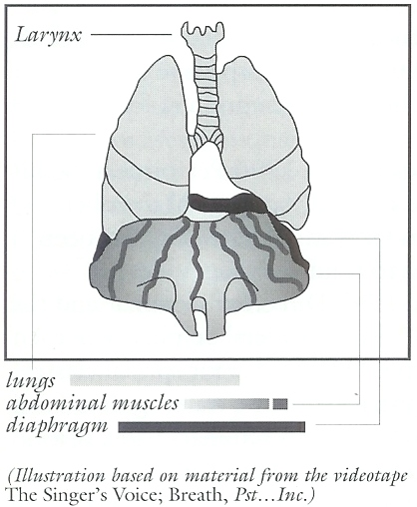

- Inhalation

- Taking in too much air wastes energy and creates unnecessary tension in both the breathing mechanism and larynx. ONLY TAKE A COMFORTABLY DEEP OR FULL BREATH. LEARN HOW TO USE THE BREATH EFFICIENTLY. If you have good breath control and are producing good vocal sound it is surprising how long you can sing on a rather small breath.

Exhalation

- Maintain expansion around the middle part of your body
- Lower abdomen naturally pulls in and up as air is expelled

Phonation: PLAY BALL!

- Phonation is the process of producing vocal sound in either speech or singing by the vibration of the vocal folds. It occurs in the larynx when the vocal folds are brought together (approximate) and breath pressure is applied to them so that vibration may ensue.

- A sound wave is created; when it reaches the upper resonating air spaces unimpeded by throat tension the PITCHER AND CATCHER HAVE PLAYED BALL!

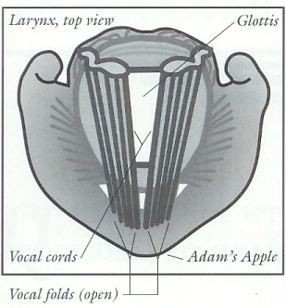

VII. Three Phases of A Musical Tone

- Attack – no glottals!
- Sustention – breath stays in body!
- Release – precise, with support!

VIII. Exercises

Strengthening/Breath Capacity and Management Exercise – “sssssss”/Yoga Breathing

Strengthening Exercise – “sssss” staccato

Breath Management Exercise – Breath 4, Hold 4, Exhale 4 (do 4 times)

Breath Management Exercise – Sip and “ssss”
- Exhalation of air with no sound – memorize feeling of a totally relaxed throat
- Exhalation of air, then add sigh – sigh is supported completely by air
- Exhalation of air, then add musical tone – the tone rides on top of the air
- 2 Blows, 2 Ha’s – arms over head, air only, then add pitch
- Ha 2, 3 Hold – perform on Ha, Heh, Hee, Ho, Hoo
- Hip Hip Hip Hip Ha Ha Ha Ha, etc. -- 1234555554321
- Staccato Legato – 3-1-5-1/3-1-5-1 (first sequence staccato, second sequence legato)

GOALS:

- Practice the exercises to attain good singing body alignment and to strengthen the lower singing muscles’ ability to expand and control the breathing mechanism.
- Practice in front of a mirror so that it becomes automatic!

- NO INITIATION OF SOUND WITH THROAT MUSCLES!! USE YOUR BREATH!!!
IF YOUR THROAT IS INVOLVED, THE BALL CAN’T MAKE IT TO THE CATCHER!
- Practice the non-vocal and vocal exercises so that you can achieve “balanced phonation” – coordinated exhalation and phonation. This is “singing on the breath.”

BODY ALIGNMENT GUIDELINES

1. Feet:
a. One foot slightly ahead of the other
b. Weight evenly distributed
c. Feet comfortably apart for good balance
d. Weight forward on balls of feet – heels on the floor
2. Legs: FOUNDATION!
a. Technically, aren’t completely relaxed since they’re helping to support the body
b. Freely flexible and ready to move at all times
c. NO RIGIDITY
3. Knees:
a. Relaxed and flexible
b. Loose and ready to be moved; soft
4. Hips and Buttocks:
a. Hips square
b. Buttocks tucked under to straighten the small of the back
5. Lower Abs – Tucked in comfortably
6. Upper Abs – Free to move at all times
7. Lower Back – No swayback
8. Upper Back and Spine:
a. Stretched upward
b. Feeling of lifting and gentle stretching from head, along the spinal column, maintained at all times
9. Chest:
a. Comfortably high and wide
10. Shoulders:
a. Rolled gently back and relaxed down
b. NO TENSION
11. Arms and Hands:
a. Hanging naturally at sides
b. Slight elbow bend
c. No tension in hands or fingers
12. Head:
a. Alexander Tilt – head sits on a rocker joint on spine and rocks back and up
b. Head (eyes) level, chin parallel to floor, slightly tucked to lengthen neck
c. Head can move easily from side to side

From Debbie Cleveland’s class on Vocal Production:

1. Starting from the ground up:
a. Toes – pressed
b. Knees – flexed
c. Pelvis – tilted
d. Ribcage – lifted
e. Shoulders – relaxed
2. Using different terminology:
a. The head carries the body
b. Stand like Queens (balance the crown!)
c. Emulate the look of a great singer (Pavarotti)
d. A string suspends you by the sternum and crown of your head

FAVORITE QUOTES ON BREATHING
Most attributable, but paraphrased, to Dale Syverson

“Breathing is about the music, not about survival.
We don’t care if you’re dying.”

“Breathing is an important part of musicality.
Breathing MUST be connected to the passion! Set the mood with the breath.”

“Extravagance in all things breathing. Breathe extravagantly, then
spend the air, spend the air, spend the air!

“Anything you do to add air, taking the muscle out, adds sound.”

“A rest is NOT an instruction. It’s just an absence of pitch,
NOT the stopping of emotion, breath involvement, or good singing.”

AND FINALLY,

“I breathe when I have to.”

Ethel Merman

