Balancing and Blending the Voice
with Horizontal Singing

“…singing is not a natural process; it is a highly skilled art, and requires highly developed
muscle reflexes. Singing does not demand much muscle strength, but it does call for a high
degree of muscle coordination.” James McKinney

Key Information:

“Voice Blending/Balancing” is a higher level skill and, to be achieved, needs the following to be mastered:

- CATCHER AT THE PLATE! – Open the vocal tract
- Relaxed position of the tongue, jaw and lips
- Gently lifted and expanded soft palate, open nasal passages and throat; a.k.a., Inside Smile, beginning of a yawn feel

- PITCHER ON THE MOUND! – Breathe abdominally
- Body is aligned with good posture
- Intercostal (rib), back, and upper and lower abdominals expand for a full breath
- Use inhalation imagery, if helpful

- PITCHER AND CATCHER PLAY BALL! – Phonation on the breath
- Breath support established immediately before singing
- Breath control utilized as required by the music and the message
- No glottal attacks
- Energized sustention and release of musical tone

- The Vocal Chain (Roland Wyatt)

BREATH

PITCH

TONE

TEXT

ACTIVATOR

VIBRATOR

RESONATOR

The Foundation of Relaxation and Vocal Readiness

III. The Concept of “Vocal Placement” in Your Resonating Air Spaces

- There is nothing in the human mechanism that enables you to place your sound!
- Sound waves move out from vocal cords and fill any vocal resonator to which they have access
- You feel the vibrating sensations as the sound waves fill those resonating air spaces – the more you make the air spaces accessible, the more you’ll feel the vibrations and the more resonance you will create – RELENTLESS OPENNESS!!
- Sound waves create different resonance and tone quality in different resonating air spaces
- The goal is to achieve a balanced resonant vocal tone

IV. Horizontal Singing – “The Think System”

- Helps you achieve:
- A balanced vocal tone, which is
- A blending of the good aspects of ALL the resonating air spaces
- A lot of hard palate vibration and mouth resonance – RING!!
- Thinking your tone forward or backward as you sing from high notes to low notes; this changes the available air space as required by the note and ensures resonance is always present

- A blended voice, which is
- A voice which appears uniformly and consistently produced – no breaks
- A mix of the lighter and heavier aspects of your voice
- An “equally weighted” voice
- A coordinated voice
- Constantly adjusting as you sing higher or lower
- Energy
- Space
- Depth
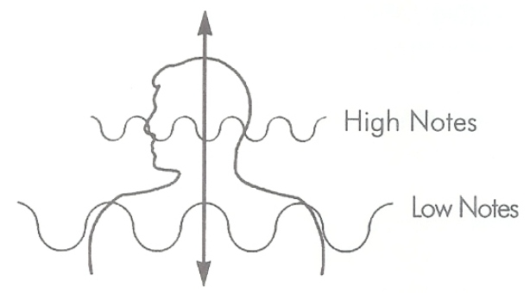
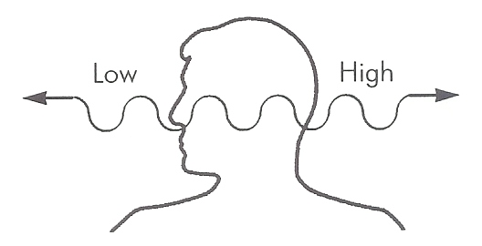

V. EXERCISES

- Sing on an “n” 5 note descending
- “Hung” 5 note descending; then “Hung-ah” 5 note descending
- Ning ee (Ning ah) double 5 note descending
- Li Li Li Arpeggio – the Campbell’s soup melody to feel horizontal movement
- Top Down – 5 - 1 - 5/1 - 5 – 1 to blend the voice
- 8 – 5 – 3 – 1 on “hoo” or “soo” to blend the voice
- 123,234,345,456,543,4321 on any vowel sound; begin with an “h” – blending
- “Hee” your vocal line, finger in teeth, to identify the space and place!

GOAL: CONSTANT, BALANCED VOCAL RESONANCE WITHIN A FREELY PRODUCED, CONSISTENT, AND BLENDED (MIXED) VOICE!

Practice the vocal exercises so that you can achieve this VOCAL COORDINATION!

