HANDOUT #2

Class Objective: To provide singers vocal techniques and exercises to assist them in developing the necessary skills to achieve a well-produced voice.

Resources
Judging Category Description Book - Sweet Adelines, International
The Perfect Blend - Timothy Seelig
Sing, Baby, Sing!: A Springboard to Artistry, by Darlene Rogers, Dale Syverson & Peggy Gram
The Complete Choral Warm-up Book, by Russell Robinson & Jay Althouse

Unit Approach to Vocal Production
- Proper vocal production is the foundation upon which good sound is built.
- It is the first and foremost requisite to producing unit sound.

The Five Characteristics of a Well-produced Voice
- The voice has consistency, with a seemingly even tone quality from the lowest to the highest tone.

Warm Up #19 – Bubble, Hum or Nng
- The voice has both ring, giving a sense of focus to the sound, and roundness, emanating from a throat that is open and free from tension.
- The voice has energy and words flow smoothly.
- The voice is free from tension and has warmth and color.
- The voice is flexible and capable of a wide variety of dynamics.

The Five Elements of Vocal Production
- Posture
Correct posture is fundamental for proper breathing for singing.

2. Breathing
There is no shortcut to proper breathing, it is the foundation of good singing.
Breathing Exercise

3. Phonation
The action of the vocal chords in speaking and singing

Reminders
- Focus the sound. Good for tuning, resonance, unit sound
- Bubble, hum or Nng
- Can also be sung on an ‘M’ or “N”
- Source - The Perfect Blend, Dr. Timothy Seelig

4. Resonation
The amplification and reinforcement of the tones produced
Reminders
- Start on Eb and repeat, going up by half steps
- Keep the jaw relaxed
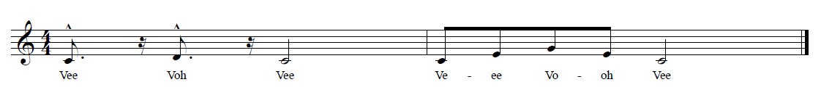
- Shift to AH when you get to G as the starting note and keep the sound consistent

Warm Up #4 – Nng to AH

Warm Up #8 – Loo Eee

Warm Up #27 Vee-Voh- Vee
- No dump age on the low note!

Reminders
- Good for keeping forward placement and resonation during ascending pattern.
- Make sure the OO on LOO has space.
- Focus on maintaining forward placement and resonation while descending.
- Careful not to pinch the EE as you ascend.

Reminders
- The ‘V’ brings the sound forward.
- Work on keeping the sound connected on the 2nd measure.
- Maintain the singing space as you ascend.

5. Articulation
The process by which sounds are shaped
Reminders
- Good for articulation.
- The ‘Z’ brings the sound forward.
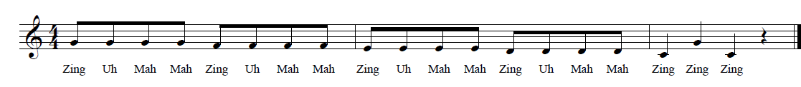
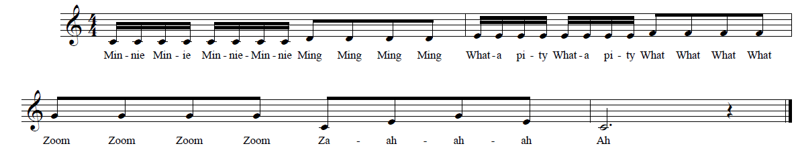
- Try to keep the consonants forward.

Warm Up #25 Zing-a-Mah-Mah

Warm Up #28 Minnie Minnie
- Work for a consistent sound on the last three ‘Zings’.
Source: The Complete Choral Warm-up Handbook by Russell Robinson & Jay Althouse

Reminders
- The ‘M’ brings the sound forward.
- In the 2nd measure keep the sound connected, don’t sing hard ’T’s.
- Keep the sound connected on the ‘ZA-AH’.

Interval Work - In our art form another skill that will improve our singing is the development of accurate interval singing. A cappella music requires ear training and accurate intervals.

Interval Exercises
Reminders
- Great interval work and ear training
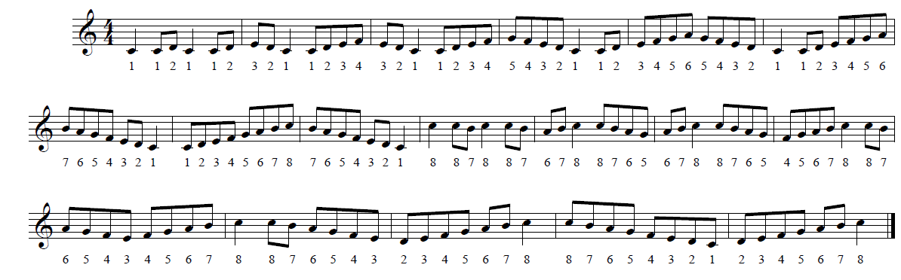
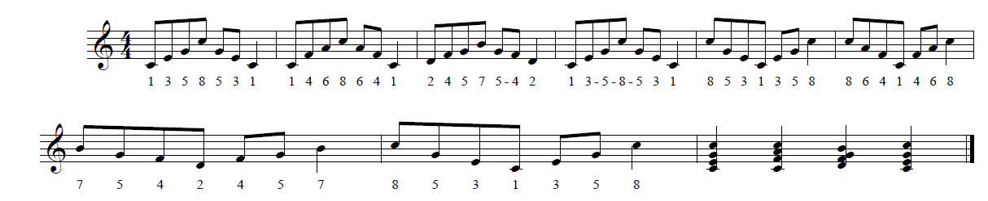
- Don’t breathe after ‘1’, keep ‘1’ part of the journey, not a destination. Same thing on ‘8’

Warm Up #32 Scale Patterns

Warm Up #33 1-3-5-8-5-3-1
- Good exercise to assist in developing ‘sneak’ breathing.
Reminders
- Good for ear training.
- Focus on singing the arpeggio with lift and air.
- Keep the sound connected.

The key to the development of the vocal skills necessary to achieve a well-produced voice is a consistent and focused approach to vocal production every week.

