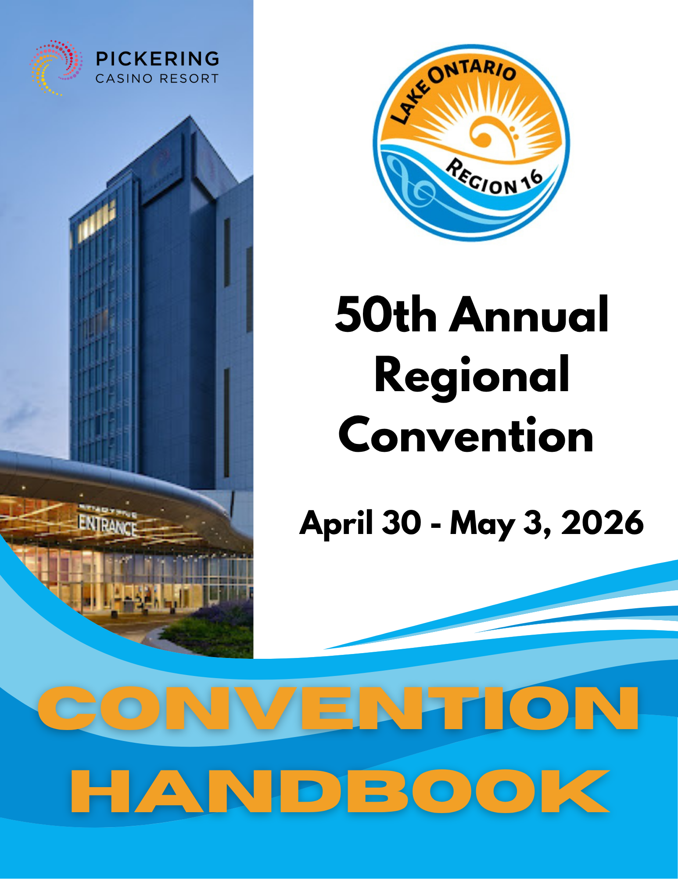

Table of Contents

- A WORD FROM THE CRC 3
- CONVENTION TEAM DIRECTORY AND SUMMARY OF DUTIES 4
- REGIONAL ASSESSMENT 5
- OFFICIAL JUDGING PANEL 5
- ROLE OF THE CHORUS COMPETITION LIAISON (CCL) 5
- CONVENTION VENUE AND HOTEL INFORMATION 7
- HOUSING INFORMATION 7
  - Convention Hotels 7
  - Rates 8
  - Room Lists 8
  - Deadline 8
  - Cancellation Policy 8
  - Hotel Method of Payment 8
  - Check-in Procedure 9
  - Hotel SMOKE-FREE policy 9
- CONVENTION REGISTRATION: ALL EVENTS TICKET (AET) 9
  - OVERVIEW 9
  - AET AND SINGLE EVENT PRICES (NEW INFORMATION) 11
    - Members 11
    - Prospective Members, Non-Members and Members at Large 11
- CONVENTION ACTIVITIES 12
  - MASS SING 12
  - Webcast 12
  - Vendors 12
- IMPORTANT DATES 12
  - Forms and Payments 12
    - Regional Forms 13
    - International Forms and Entry Fees 13
- COMPETITION SERVICES 16
  - Convention Schedule 16
  - International Contest Rules 17
  - Riser Configuration 18
  - Thursday Night Briefing, April 30, 2026 19
  - Rehearsals 19
    - Optional Rehearsal Time and Function Space: 19
    - Assigned Regional Rehearsal Time 20
  - Competitors Needing Special Assistance 20
  - Awards 20
    - International Awards 20
    - Regional Awards 21
  - Distribution of Results 22
  - Competition Supplements 22

- A WORD FROM THE CRC
Welcome to the Pickering Casino and Resort, and to Region 16’s 50th annual convention and competition!
As we embark on this exciting time of new beginnings, we are thrilled to welcome you back to this beautiful venue. We look forward to reconnecting with old friends, making new ones, and experiencing another successful competition together. We welcome three new choruses to Region 16; Acappella Sounds Chorus, Grand Harmony Chorus, and Sounds of Superior Chorus.
Key Information for Planning:
- Convention 2026 Registration Fee: This is included in our members regional assessment, so no need to collect or remit money when registering your chorus. For members unable to attend in person, we will be streaming the Contest live on Youtube instead of the usual webcast.
- Non-members wishing to attend can purchase tickets online through Ticketmaster or at the Pickering Casino box office. We will provide links in an eBlast once our event is activated on the ticketing system. Both one-day and two-day tickets are available. Please refrain from registering non-members with your chorus.
- Hotel Registration: The process has changed slightly this year. Chorus Contact Liaisons (CCLs) will work directly with the hotels after space is allocated by our Registration and Housing Coordinator, Nancy Mulholland. CCLs will reserve their block of rooms with one credit card per chorus.
- Two-Night Minimum Stay:
PICKERING CASINO HOTEL – There is no 2-night minimum stay required at this hotel.
HILTON GARDEN HOTEL – This hotel requires a 2-night minimum stay as per our contract. We have placed choruses from out of town in this hotel who are likely to require a minimum of two nights during the Convention.
- Master Housing and Registration Forms: Be sure to carefully read through these to capture all changes. This form will be sent directly to your CCL.
Thanks to the Team
Convention and competition wouldn’t be possible without a dedicated team. Huge thanks to this year’s convention team. (See their contact info and responsibilities on the next page!) Their hard work ensures everything runs smoothly and on time. We are honoured by your trust and patience, and we look forward to reuniting with you in Pickering in spring 2026!
Be sure to fully read this convention handbook for valuable information as you prepare for competition. While the content remains unchanged, we will send out eBlasts with updates—so keep an eye on your inbox! These frequent communications will guide us all as we finalize arrangements. We will host a Zoom session for chorus leadership and quartets in early December so make note of your questions as you go through the handbook.
If you have any immediate questions or concerns, don’t hesitate to reach out—we’re just an email or phone call away. Working together, we always achieve incredible results, and we continue to uphold our region’s well-earned reputation within SAI.
Warm regards,
Cathy Stovold
Chair, Regional Convention (CRC)

- CONVENTION TEAM DIRECTORY AND SUMMARY OF DUTIES

The convention team reports to the Regional Events Coordinator, Emily Hirtle, who acts as liaison with the Regional Management Team.
Team Member / Contact Information | Area of Responsibility
Chair Regional Convention  Cathy Stovold  607 - 90 Orchard Point Road, Orillia ON L3V 8K4  (705) 791-4677 / cathystovold7@gmail.com | Oversees everything that has anything to do with convention activities and coordinates backstage hospitality. Liaises with contest venue and hotels. Negotiates all contracts.
Competition Coordinator  Shelley Snoulten  265 Miller Park Ave., Bradford, ON L3Z 2R4  (289) 879-6748 / shelleysnoulten@gmail.com | Oversees everything that has anything to do with contest activities, including the scheduling of rehearsal and function space.
Finance Coordinator  Selena Novak  76 Sherwood Road East Ajax L1T 2Z2  (647) 242-3653 / financeregion16@gmail.com | Assists with everything that has anything to do with money! Signs all contracts.
Official Panel Liaison (OPL)  Sue Heighway  673 Berwick Crescent, Oshawa, ON L1J 3E6  (905) 409-8848 / sheighwayreg16@live.ca | Takes care of the judges’ requirements. Coordinates their transportation.
Assistant Panel Liaison (APL)  Vacant | Assists the OPL with all their responsibilities.
Registration & Housing Coordinator  Nancy Mulholland  8556 Line 2, RR 2 Arthur, ON. N0G 1A0  (647) 897-9672 / nancymulholland56@gmail.com | Registration  Responsible for convention registration.  Housing  Responsible for all sleeping room bookings.
Audio/Visual Coordinator  Meaghan DeClerq  1037-299 Roehampton Ave, Toronto ON, M4P 1S2  416-453-2991 / meaghan.declerq@gmail.com | Coordinates all of our audio/visual requirements for contest. Coordinates set-up of webcast/streaming of contest via YouTube
Awards Coordinator  Barb Jacobs  901 Birch Ave., Milton, ON L9T 3N3  (905) 693-9777 / btjacobsmilton@gmail.com | Coordinates all international and regional awards – including getting the hardware!
Communication Coordinator  Joanne Mitchell  62A Roseland Drive, Etobicoke, ON. M8W 1Y5  (647) 888-9816 / jmmitchell72@gmail.com | Responsible for convention communication, the publishing of the convention handbook, design and printing of the contest program and program advertisements.
Transportation Coordinator  Suzanne Askin  33 Weldrick Rd. PH 14 Richmond Hill, ON L4C 8W4  (905) 442-2818 / suzanne40@rogers.com | Prepares the schedule for chorus and quartet pick-ups on contest day and coordinates the busing when required.

- REGIONAL ASSESSMENT

In accordance with international by-laws, a member is deemed to be in good standing if their international dues and regional assessment are paid in full. If a member is not in good standing, they are ineligible to compete. Regional assessments are due November 30

- OFFICIAL JUDGING PANEL

SOUND – Patty Cobb-Baker

MUSIC – Carolyn Schmidt

EXPRESSION – Kerry Mauney

VISUAL COMMUNICATION – Di Porsch*

PANEL SECRETARY – Heather Reimnitz

* Indicates Panel Chair

Trial scoring judges may choose to come practice in our region. Their decisions are made after the official judging panel has been appointed. If any are assigned, we will notify you by eBlast and include the information in the competition supplements that will be issued 45-days prior to contest.

- ROLE OF THE CHORUS COMPETITION LIAISON (CCL)

All convention information is disseminated via the Communications Manager of the convention team, Joanne Mitchell, who maintains a master group distribution list. Each chorus appoints their CCL. We asked via the intent to compete survey to provide the name of the chorus CCL and alternate CCL. Please ensure that any changes to the chorus CCL or alternate contact information is immediately submitted to Joanne at jmmitchell72@gmail.com

The CCL acts as the conduit of information between the convention team and their chorus. They ensure that all forms and applicable payments are submitted by the specified deadlines. Because all information is communicated by e-mail and posted on the regional website, chorus CCLs must be online and fluent in using Microsoft Excel. Duties include:

Chapter Communication
The CCL shares all regional convention information with chorus members, president/team leader and director. They verify with quartets to ensure the information has been received directly. If not, remind them to provide contact information to Joanne Mitchell at the email above.

Convention Team Communication
Written and/or verbal communication with appropriate convention team members as required.

The CCL is responsible for coordinating the convention registration and housing for chorus members, rehearsal/function space requirements for the chorus, ordering photos and video for the chorus and members, coordinating the distribution of Ziploc bags for chapter members’ individual belongings, and arranging for riser row bag custodians. Details can be found in the appropriate section of this handbook.

Housing
- Collects rooming requirements for their chorus and guests and submits the online Master Registration and Housing file (Excel spreadsheet) to the Registration and Housing Coordinator.
- The Master Housing file (Excel spreadsheet) is sent to the hotel by the Housing Coordinator.
- When directed, the CCL will provide the hotel contact with one credit card number. One single credit card is required to reserve the entire block for the chorus.
- Once the Master Housing file (Excel spreadsheet) has been submitted, all changes and additions to housing are made directly through the hotel. Changes will be made only on specific dates as noted below:
    - March 2, 2026 – first date for reservation amendments
    - March 30, 2026 – second date for reservation amendments
    - April 20, 2026 – third date for reservation amendments
    - April 27, 2026 – FINAL date for reservation amendments

Rehearsal & Function Space
The Competition Coordinator will assign all choruses one (1) hour of rehearsal time on both Friday and Saturday. Times will be based on order of appearance.

Due to limited rehearsal space, EXTRA function space for rehearsals, make up checks or private meals will not be available through the convention. We will provide contact information for external spaces in the area should you wish to arrange for additional space privately.

Medical Information
Chorus CCLs should remind their choruses to prepare for any medical emergency that may arise. Out of country medical insurance is highly recommended for American members. This insurance must be obtained prior to leaving for the convention. Emergency medical phone numbers are available backstage at The Arena.

- CONVENTION VENUE AND HOTEL INFORMATION

CONVENTION VENUE

PICKERING CASINO RESORT
The Arena
888 Durham Live Ave, Pickering, ON L1W 0C1 Telephone (833) 629-0552

HOTEL

PICKERING CASINO RESORT HOTEL
888 Durham Live Ave, Pickering, ON L1W 0C1 Telephone (833) 629-0552

- IMPORTANT NOTE: The card used at check in places a hold on the card. If that card is not used to pay all or a portion of the room at checkout, the hold is not immediately released. The release time is as per the individual’s bank and credit card company. The hotel has no authority or means to change the hold period.
- Free internet at the hotel
- Mini fridge and coffee maker in rooms
- Pool/hot tub/sauna
- 6 restaurants and 3 bars/lounges on site
- Free parking on site.
- If arriving by bus, please be sure to indicate it on the room list summary sheet and contact the hotel for specific unloading and parking instructions.

HILTON GARDEN INN
500 Beck Crescent, Ajax ON L1Z 1C9 Telephone: 905-686-9400

- IMPORTANT NOTE: The card used at check in places a hold on the card. If that card is not used to pay all or a portion of the room at checkout, the hold is not immediately released. The release time is as per the individual’s bank and credit card company. The hotel has no authority or means to change the hold period.
- Complimentary Self-parking
- Complimentary wired and wireless internet
- TV, mini fridge, microwave, Keurig coffee machine
- Indoor pool and whirlpool
- Fitness Centre
- Garden Grill Restaurant & Bar serving breakfast and dinner with room service.

- HOUSING INFORMATION

Convention Hotels

Everyone will be housed at the Pickering Casino Resort or the Hilton Garden Inn. Priority will be given first to competitors and second to guests when assigning rooms within rooming blocks. If we find ourselves in a situation where we are short of rooms due to circumstances beyond our control, non-competing members and guests may have to be moved to an alternate hotel. If you or your guests are asked to move, please know that it is because we have NO OTHER option.

Sleeping rooms at both hotels have either two standard queen beds or one standard king bed.

In accordance with fire regulations, the rooms cannot be occupied by more than four (4) occupants per room.

Charges may be imposed for soiled linens, towels and facecloths that cannot be cleaned by their industrial laundering equipment. It is recommended that each member bring face wipes (or cheap dollar store facecloths) to remove make-up to avoid incurring damage charges.

Rates

PICKERING CASINO RESORT
Regular Room: $179.00

All rooms subject to the following taxes
HST = 13%
Resort Fee = $9.99
Municipal Accommodation Tax (MAT) 5%

Rate is based on single/double occupancy. There is a $30 charge for each additional guest. There is a maximum of four (4) guests per room.

HILTON GARDEN INN
Regular Room Rate: $189.00
All rooms subject to the following taxes
HST 13%
Municipal accommodation tax (MAT) 5%

Rate is based on single/double occupancy. There is a $10 charge for each additional guest. There is a maximum of four (4) guests per room.

Room Lists

2026 Master Registration & Housing file

The above form must be used to reserve hotel rooms. Please carefully read the instructions in the spreadsheet. Only use the spreadsheet in Excel to preserve the formatting and formulas. The integrity of the form may be compromised if opened using any other spreadsheet program. Much of the spreadsheet is locked to prevent formulas from being lost or altered. This automated form will be sent to each CCL directly and MUST be used.

Deadline

Rooming requirements must be received by the Registration and Housing Coordinator no later than January 23, 2026. Unsold rooms will be released back to the hotel no later than March 20, 2026 as per our contract, and block rates will no longer be guaranteed.

Cancellation Policy

Choruses are responsible for all rooms reserved. Hotel cancellation policies apply.

Pickering Casino Hotel – 48 hours prior to check-in
Hilton Garden Hotel – 7 days prior to check-in

Hotel Method of Payment

On the rooming list tab, fill out the form and submit to the Coordinator, Nancy Mulholland without the credit card information. The hotel will provide an authorization form. Only one per chorus is required to be completed and returned to the hotel. Please note that ONLY the CCL is allowed to contact the hotel on behalf of their chorus. Individual members or guests are not to contact the hotel. Any requirements are to be communicated via the CCL.

Credit card information must be sent to the hotel within one week of receiving information from the Coordinator, otherwise the rooms will be considered a “no show”. Please note that the credit card provided for the hotel block is a preauthorization and will not be charged in advance of the event. As mentioned, at checkout, the room charges can be divided equally amongst multiple cards.

Check-in Procedure

At check-in, one guest from each room will be required to provide a credit card number for the room. This places a hold on the card. At check-out, guests can use one or multiple credit cards, but please make sure to notify the front desk at check in that you would like the bills split. The amount will be divided equally by the number of occupants in the room. Please do NOT charge incidental charges, like restaurant meals for example, to the room.

Check-in time at BOTH Hotels is 4:00 p.m. (every day) and checkout is 11:00 a.m.

Hotel SMOKE-FREE policy

Pickering Casino Resort Hotel and Hilton Garden Inn are a smoke free resorts. To protect the smoke-free environment, the resort will post a $500.00 cleaning fee to the account of any guests who smoke in their guest room.

- CONVENTION REGISTRATION: ALL EVENTS TICKET (AET)

REGISTRATION OPENS December 10, 2025 and CLOSES January 23, 2026

OVERVIEW

- The chorus CCL must complete the 2026 Master Registration & Housing file which will be sent to each individual chorus CCL for completion by JANUARY 23 2026
- Drop-down menus make it simple for choruses to register competing* or performing members**, and non-competing members on the same form.
- New members registrations after November 30th, 2025 will be made via the " Zeffy link.
- All AETs will be left at the hotel for pickup by the CCL at check-in.
- Rush seating! There isn’t a bad seat in the house but come early if you want to sit with friends.
- Seats will be blocked off in the auditorium for competing quartets on Friday for when they come off stage.
- VIP seating will be provided to the Blue Ribbon Club on Friday during quartet contest only.

*A competing member is either competing in the international or open division contest at regional convention.

**A performing member is anyone who has earned entry into the international or Harmony Classic contest at the next international competition and is performing an outgoing package at contest.

AET AND SINGLE EVENT PRICES (NEW INFORMATION)

Members

A member’s all events ticket (AET) is covered by their regional assessment so there is no registration cost to attend the convention. Members must have paid their regional assessment by November 30, 2025. This requirement applies to all chorus members, both competing and non-competing, as well as chapter-at-large members, regardless of whether they are participating in a quartet.

THERE WILL BE NO NAME BADGES PRINTED. MEMBERS WILL RECEIVE A HARD VENUE TICKET (LIKE A CONCERT TICKET). THIS TICKET IS REQUIRED TO ENTER THE CASINO THEATRE. NO TICKET, NO ENTRY!

PLEASE ENCOURAGE YOUR MEMBERS TO WEAR THEIR CHORUS NAME BADGE.

Prospective Members, Non-Members and Members at Large

IMPORTANT
NEW INFORMATION ON NON-MEMBER REGISTRATION

ALL non-members, perspective members and members at large are not to register through a chorus. They may register through Ticketmaster. The ticket link will be supplied via eBlast

The following prices apply for an all events ticket (AET) OR A single event ticket bought through Ticketmaster or at the box office

- $75.00 CDN plus box office fees* for 2-day all events ticket
- $45.00 CDN plus box office fees* for 1-day single event ticket

* BOX OFFICE FEES CHARGED BY THE FACILITY:

$3.00/ticket facility fee plus $10.00/ticket service charge

- CONVENTION ACTIVITIES

MASS SING

When: 1:00 PM, Friday, May 1, 2026
Where: Pickering Casino Arena

Choruses are encouraged to wear their chorus colours and display their chorus banners!

Regional Songs:
Can You Feel the Love Come On and Sing
How We Sang Today Irish Blessing
Hallelujah Barbershop

Webcast

Plans are underway and all details will be shared via eBlast at a later date.

Vendors

Due to limited space and cost to vendors, there will be no boutique this year.

- IMPORTANT DATES

Forms and Payments

All forms listed below are posted individually on the regional website. To complete these forms, and for email instructions, please visit www.saregion16.com. You can find them at Events > Convention > Regional Forms.

The 2026 Master Registration & Housing file that was sent to your chorus is to be used for all requirements and cannot be sorted or easily printed. We have created a worksheet to help you collect rooming information from your chorus members. These are for your use only and do not need to be submitted. Final numbers must be entered into the Master Registration & Housing file spreadsheet.

11_Rooming List Work Sheet

Regional Forms

Deadline | Form Name | Action | Submit Form To | Mail or etransfer Payment To
Jan 23, 2026 | 2026 Master Registration & Housing File | Convention Registration and Housing Room List | Nancy Mulholland Selena Novak | n/a
Post Jan 24, 2025 | 9_Change and Addition Form | Changes and late addition registration | Nancy Mulholland  Selena Novak | Selena Novak Zeffy
February 13, 2026 | Program Ad – Link to form will be sent via eBlast once Zeffy activated | Program Ad Order | Zeffy | Zeffy
April 3, 2026 | Photo and Video Recording Order – Link to form will be sent via eBlast once Zeffy activated | Photo and Video Recording Order | Zeffy | Zeffy
April 30, 2026 | 2_Chorus Contact Information | Contact Information On Site | At Briefing | n/a
April 30, 2026 | 3_Quartet Contact Information | Contact Information On Site | At Briefing | n/a
April 30, 2026 | 4_Chorus On Stage Photo Cue Sheet | Photographer Cue Sheet | At Briefing | n/a
April 30, 2026 | 5_Quartet Stage Entry Cue Sheet | Traffic Pattern | At Briefing | n/a

International Forms and Entry Fees

Forms | Entry Fee | Deadline | Send To
Quartet Competition Entry Form | $125 USD | March 2nd, 2026 | SAI
Quartet Late Entry Form | $225 USD | March 17th, 2026 | SAI
Chorus Competition Entry Form | $200 USD | March 3rd, 2026 | SAI
Chorus Late Entry Form | $300 USD | March 18th, 2026 | SAI

NOTES:

- The Chair of Regional Convention and the Competition Coordinator will receive an international communiqué in December 2025 with links to competition forms and registration. We will share with you via eBlast.

In order to compete in the 2026 regional contests, the paperwork for new and renewing quartets must be submitted and processed before they can register for competition. New quartets or renewals received after January 15, 2026 will be charged additional registration fees.

You will be required to bring a number of forms to the chorus/quartet briefing. Full details will be available in the competition supplements scheduled to be published 45 days prior to contest.

- COMPETITION SERVICES

All information contained in this section will be repeated or updated in the competition supplements due to be published approximately 45 days before contest.

Convention Schedule

Thursday, April 30, 2026

4:00 p.m. Hotel(s) Check-in @ Front Desk

7:00 p.m. – 7:30 p.m. Competing Chorus/Quartet Check in (forms/information turn-in) – The Arena

7:45 p.m. – 8:45 p.m. Chorus/Quartet Briefing - The Arena

Friday, May 1, 2026

9:00 a.m. – 11:00 p.m. Assigned Chorus Rehearsals (by Competition Coordinator)

9:15 a.m. Competition Facility Inspection (By Invitation Only)

10:30 a.m. Quartet Walk-through, The Arena

11:30 – 12:30 noon Education Class - The Arena

1:00 – 1:30 p.m. Mass Sing – The Arena

3:00 p.m. Quartet Competition – The Arena

4:00 p.m. Hotel(s) Check-in @ Front Desk

Saturday, May 2, 2026

8:00 a.m. – 11:00 a.m. Assigned Chorus Rehearsals (by Competition Coordinator)

12:30 p.m. Chorus Competition – The Arena

Sunday, May 3, 2026

10:30 am – 11:30 a.m. Convention Team Wrap-up Meeting (by invitation only)

This is a tentative schedule and is subject to change.
A final schedule will be published, with location of activities, in the
competition supplements approximately 45 days prior to contest.

Education class faculty and class description will be shared via eBlast.

International Contest Rules

- Total singing time of the two separate songs or medleys performed in any Sweet Adelines competition other than an entertainment package session shall be not less than three (3) and not more than seven (7) minutes.

- Props: A reminder, staging and lighting are uniform for all contestants. No penalty is attached to the use of props or visual devices in any regional or international contest sessions. The degree to which such use enhances or detracts from the performance is reflected in the visual communication score. All props and visual devices must enter and leave the performance venue with the chorus or quartet. Storage space for any props or equipment, other than riser chairs or medically necessary items, is not provided at the contest venue. Props or visual devices requiring excessive set up time will be subject to delay of contest penalties. All contestants are required to leave the stage in the condition they found it. Anything discarded or dropped must be removed and exit the stage with the contestant. In all sessions, penalty for violation is twenty-five (25) points.

- Evaluation by Video: Choruses have the option to participate For Evaluation Only by submitting a video recording. Those who choose this method must still pay the standard competition entry fee. The official panel will evaluate the recordings prior to each regional competition. This process does not replace the existing competition rule requiring choruses to compete every three years in order to maintain their charters.

- Registration for Evaluation Only: A chorus or quartet that registers For Evaluation Only may revert back to competitor status at any time after registration. Chorus directors or presidents/team leaders and quartets must notify international headquarters in writing (by email is okay). It is recommended that this decision be made before the draw for order of appearance in order to be included in the draw. If notification is received after the draw for order of appearance, the order will not be changed to accommodate the chorus or quartet.

- Withdrawals: Chorus directors or presidents/team leaders and quartets must withdraw in writing (email is okay) to international headquarters. A phone call is not sufficient.

- Copyright Clearance: All music must have cleared the copyright process. Failure to use cleared arrangements may result in disqualification. International headquarters is responsible for administering the copyright policies and procedures.

- Quartets Qualifying for International Competition: An additional invitation to compete will be offered should the first-place quartet withdraw or elect not to compete at international. If the quartet placing first in regional competitions chooses to withdraw from international competition prior to July 1, the second-place quartet will be invited to compete. If the second-place quartet has already qualified as a wildcard or withdraws, this invitation will not extend to any other placement.

Riser Configuration

We will be using one riser configuration in 2026.

Standard Configuration11 sections of choral risers with four steps and guard rails behind the fourth level. This configuration will accommodate up to 120 members.

Please note: This riser configuration will be confirmed at the inspection. We are not anticipating any problems; however, the panel chair does have the final word.

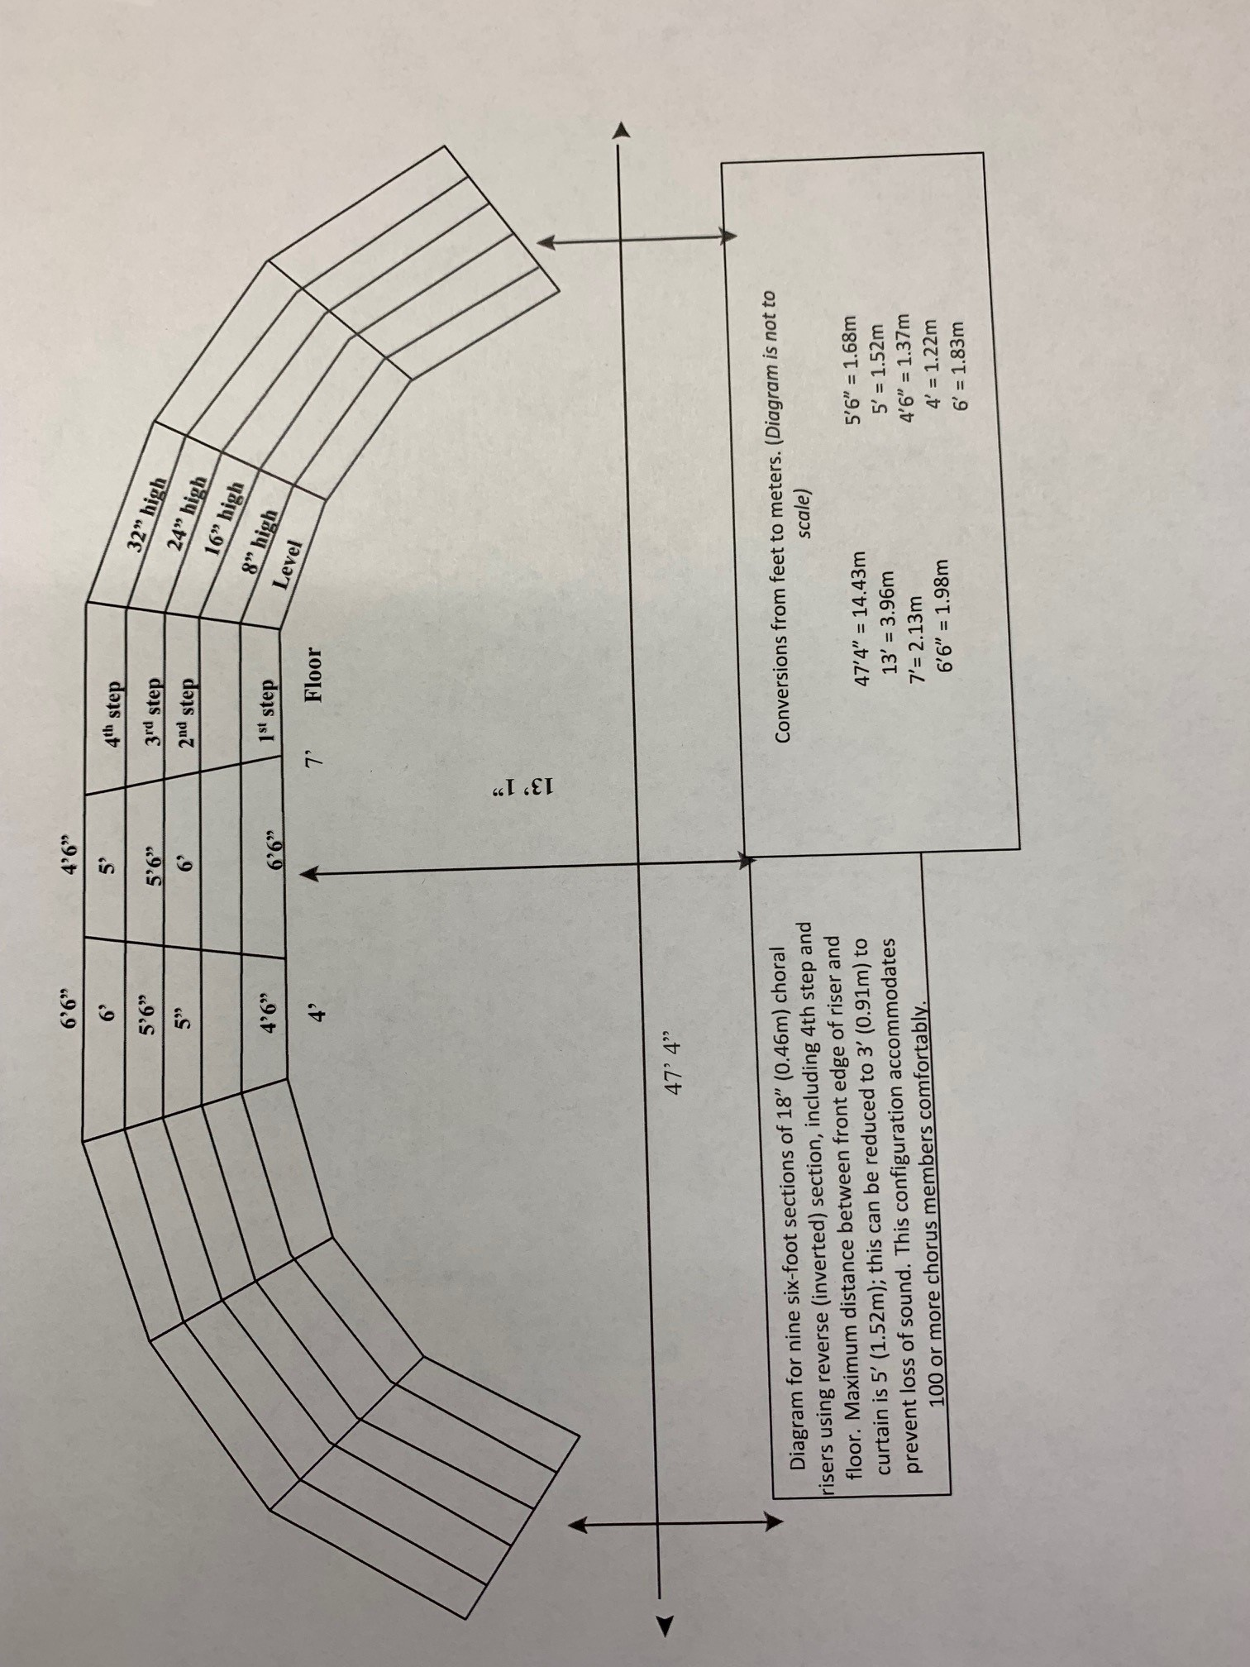

Thursday Night Briefing, Thursday April 30 2026
The combined chorus/quartet briefing will be held from 7:45 p.m. – 8:45 p.m. in the Arena. All competing chorus directors and quartets, or their representatives, are required to attend this briefing. Presidents and CCLs are welcome and encouraged to attend.

You will be required to bring the following forms to the briefing.

Choruses
- THREE (3) copies of form 6_Chorus Contact Information (single sided)
- THREE (3) copies of form 8_Chorus On Stage Photo Cue Sheet (single sided)
- THREE (3) copies of form 5_List of Competing Members and the Verification Form* (single sided).

*The List of Competing Members and the Verification form will be included in your international e-mailing. It is also available online at www.sweetadelineintl.org. Complete and attach it to the list of competing members (generated by the competing chorus). Important: We need THREE (3) copies of the form and the competing members list.

Quartets
- THREE (3) copies of form 7_Quartet Contact Information (single sided)
- THREE (3) copies of form 9_Quartet Stage Entry Cue Form (single sided)

Rehearsals

Optional Rehearsal Time and Function Space:

The Competition Coordinator will assign all choruses one (1) hour of rehearsal time on both Friday and Saturday. Times will be based on order of appearance.

Due to limited rehearsal space, EXTRA function space for rehearsals, make up checks or private meals will not be available through the convention. We will provide contact information for external spaces in the area should you wish to arrange for additional space privately.

Friday, May 1, 2026

9:00am – 11:00 pm

Note that Friday rehearsal time will be assigned in blocks of no more than one (1) hour until all choruses have had the opportunity to request space. Any remaining time blocks will then be assigned on a first come, first served basis. Do not contact the hotel directly unless instructed by Shelley Snoulten. Outside food is not permitted anywhere within the Casino Resort.

Assigned Regional Rehearsal Time

Saturday, May 2, 2026

8:00 a.m. – 12:00 p.m.

Saturday morning Regional rehearsals are assigned by the Competition Coordinator, Shelley Snoulten, based on the order of appearance. The full schedule will be included in the competition supplements due to be published approximately 45 days prior to contest.

IMPORTANT NOTE: All chorus rehearsals are on flat floor – risers are not available.

Competitors Needing Special Assistance

- Choruses with competitors needing special assistance are to notify Shelley Snoulten, Competition Coordinator (shelleysnoulten@gmail.com).

- Choruses are expected to provide any extra transportation or assistance (with wheelchairs and scooters) if required. The chorus assistant to the person using these must take the device behind the open stage and leave it at the stage left exit from the stage before they get on the risers

- Chorus personnel will set riser chair(s) on the risers immediately preceding its performance and remove the riser chair(s) immediately following the performance.

All riser chairs are to be delivered to the backstage area between 10:30 a.m. and 11:30 a.m. on Friday, May 1, 2026

- All riser chairs must be removed from the theatre complex immediately following the chorus contest session.

Awards

The culmination of each regional competition is the announcement of results and presentation of awards. Sweet Adelines International policy states that the judging panel chair announces only awards designated by the international organization. The panel secretary tabulates results for these designated awards. Additional awards, such as trophies, plaques, etc., provided by the region to the winners of international awards, may be presented at the time the announcement is made.

International Awards

Internationally sponsored chorus competition awards include the following divisions:

Division A Chorus
12-25 performers (members) on stage, not including the Director(s)

Division AA Chorus
26-50 performers (members) on-stage, not including the Director(s)

*Note as per the announcement from international, these numbers have changed from previous years.

All contestants are eligible to place in the top 5. The following placements are designated as Sweet Adelines International awards:
1st - 5th Place Quartets
1st - 5th Place Choruses
1st - 3rd Place Division A Choruses
1st - 3rd Place Division AA Choruses
Most Improved Chorus

To be eligible for the most improved chorus award, a chorus must:

- Have competed in the immediately preceding regional competition.
- Have at least 12 singing members on stage.
- A minimum score is no longer required for eligibility for the most improved chorus award.

Regional Awards

The following regional awards are presented after the international awards have been announced:

- Novice Director award is presented to a director who has not competed as a director in more than two (2) barbershop harmony singing organization competitions and whose chorus receives the highest overall point total of those eligible and whose score is at least 400 points (mid-C level). This award may be won only once.
- York Harmony Novice Quartet award is presented to the highest scoring quartet having no more than one member who has competed previously in any barbershop harmony singing organization competition and whose total score is at least 400 points (mid-C level).
- Ev Rivers Memorial Most Improved Quartet award is presented by the Greater Kingston Chorus to a quartet scoring at least 360 points who competed in the immediately preceding annual regional quartet competition with the same quartet name and the same personnel as the preceding year. Quartets performing for evaluation only are not eligible for this award. There is no limit to the number of times a quartet may win this award. If a tie occurs between two or more eligible quartets, the trophy will be shared.
- North Metro Coaching Achievement award is presented to a person, male or female, residing within the geographic boundaries of Region 16 who has made an outstanding contribution to a chorus(es) or quartet(s) in a coaching capacity. Choruses are contacted directly for nominations.
- Leadership Excellence award is presented to a Region 16 Sweet Adeline who has made outstanding contributions to their chorus and/or the region in a leadership capacity. Choruses are contacted directly for nominations.

IMPORTANT NOTE
Previous year’s recipients must return all trophies and plaques to Barb Jacobs, Awards Manager, at the chorus/quartet briefing, Pickering Casino in the Arena on Thursday, April 30, 2026, from 7:00 – 7:30 p.m.

Distribution of Results

Contestant score sheet packets will be ready immediately after each contest session.

Results packets are to be picked up from the pit, stage left, at the conclusion of each contest session. Only a quartet member or the chorus director or team leader/president may pick up the score sheet packet.

Competition Supplements

The competition supplement will be published approximately 45 days prior to contest and will include the following information:

- Order of appearance
(Final draw March 23, 2026).
- Traffic pattern information (scheduled)

- Chorus/quartet briefing (briefing details and forms to be brought to briefing)

- Chorus rehearsal schedule (by sign-up and assigned)

- Riser configuration

- Procedure for handling of personal belongings while on stage

- Competitors needing special assistance (including instructions regarding notification and riser chair procedures)

